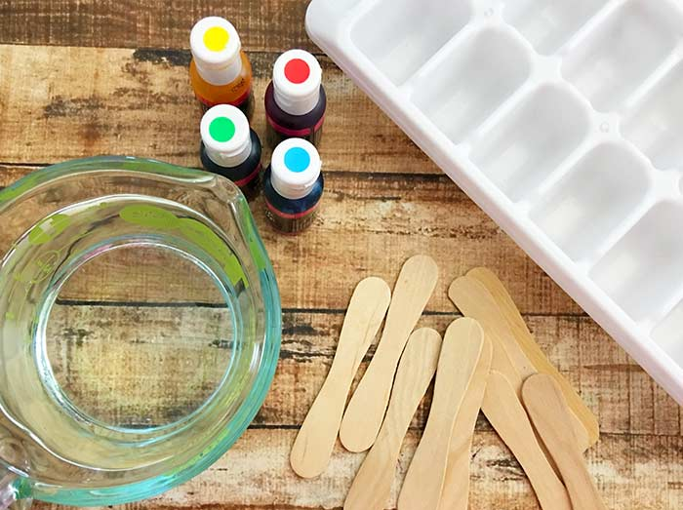
Painting with Ice – Make Your own Ice Paint
You will need:
- Water
- Ice cube tray
- Food colouring
- Lollipop sticks
- Paper

Step 1
Fill your ice cube tray with water,
ensuring that they are not filled to the
top. Then carefully add a few drops of
food colouring to each section.

Step 2
Place a lollipop stick into each section
and carefully place the ice cube tray in
the freezer. It can take between 4 to 6
hours to freeze or overnight for better
results.

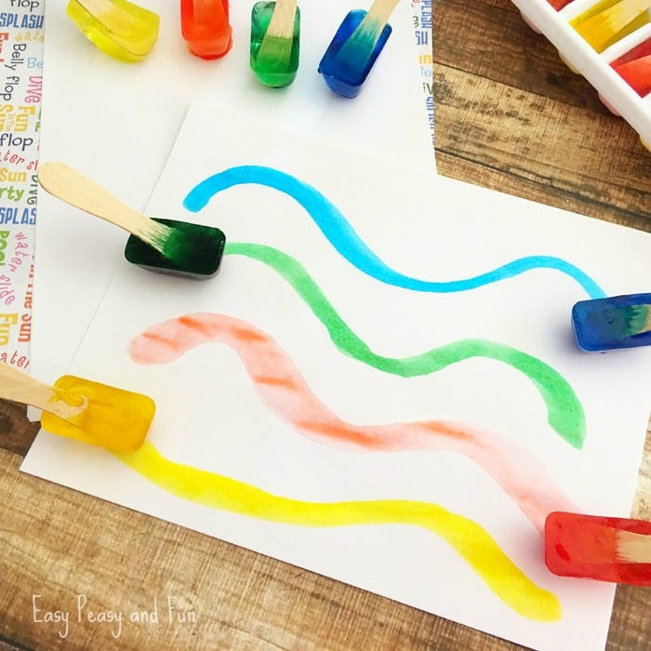
Step 3
Take the ice cube tray out of the freezer
and gently wiggle the lollipop stick and ice cube to remove it.

It is now time to get creative and paint with your ice paints!!

Don’t forget you can experiment with mixing two or more colours together. This can either be done before freezing with the food colouring or after with the ice cube paints!

