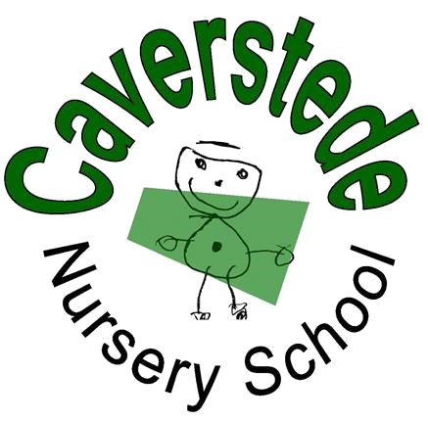How has our Nursery helped your child/ren and family?

Please use the space below for your comments, stories, photos or pictures, thank you!

(please feel free to carry on over the page if you have lots to say!)

Please tick the box if you would be happy for us to share your comments

Name: (optional) ………………………………………………………………………………….

What is Parent View?
Parent View is an online questionnaire for parents and carers to feed back on their child’s school at any time of the year as well as at the time of an inspection. We would appreciate it if you could log onto the site and give your responses to 12 simple questions such as ‘My child is happy at this school’ and ‘My child is well looked after at this school’.
Please visit; http://parentview.ofsted.gov.uk. Thank you.

Caverstede Nursery School; Caverstede Road; Walton; Peterborough; PE4 6EX - tel; 01733 571742 - www.caverstede.peterborough.sch.uk

